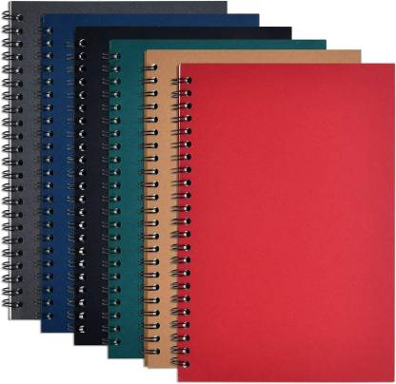 SPIRAL NOTEBOOK

RYANA CALENDARS is selling wonderful SPIRAL diaries in different colors and designs! It contains of great designs!

RS 520